**ADA Web Design**

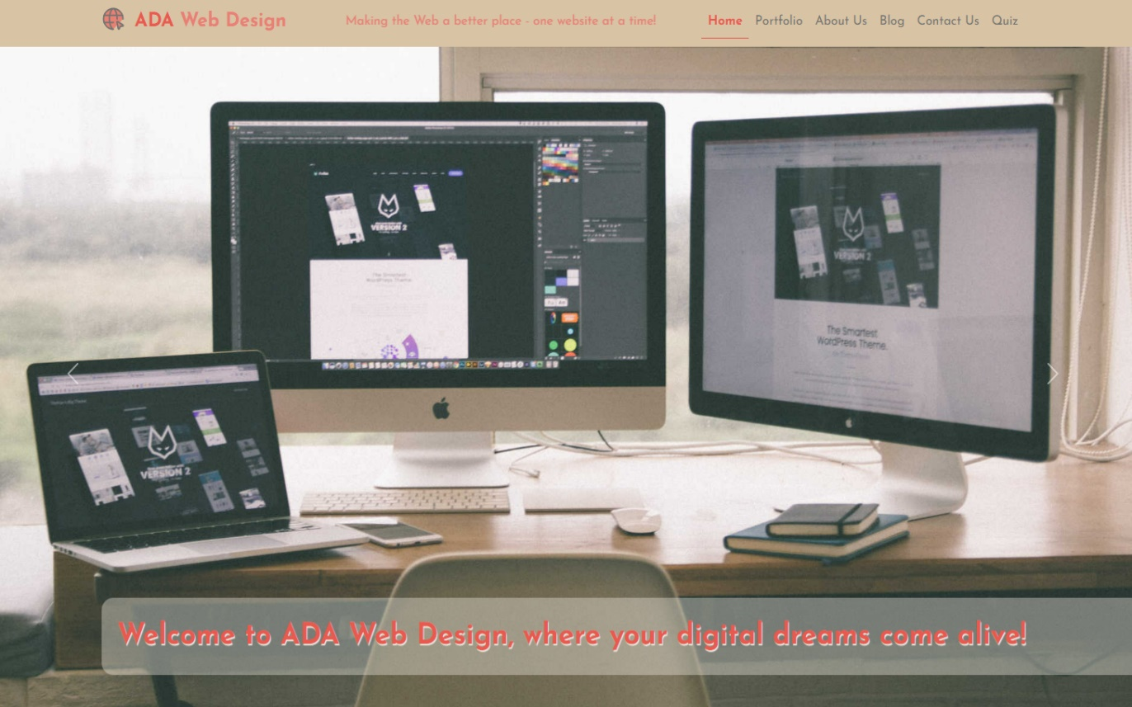

Website link: <http://nci-web-design-project.s3-website-eu-west-1.amazonaws.com/>

GitHub repository: <https://github.com/adamfanslau/nci-web-design-project>

Video presentation link: [ADA-WEB-DESIGN.mp4 (sharepoint.com)](https://studentncirl-my.sharepoint.com/:v:/g/personal/x23185937_student_ncirl_ie/EeeEFV4zw3ZOu43gEZwIO2MBpPfE6v1S5wwjiilFgr3xHg)

Adam Fanslau

Anastasiia Kovalenko

Daniel Lemos

Date: 1st December 2023

Table of Contents

1. Executive Summary 1

2. Project Work 2

3. Design Process 3

4. Testing & Responsiveness 8

5. Conclusion 14

6. References 15

# Executive Summary

Why did you decide on this idea, what problem are you solving, what is the market size, etc.? Provide an overview of your chosen company.

Also, pop in the link to your deployed website:

<http://nci-web-design-project.s3-website-eu-west-1.amazonaws.com/>

Our team decided on **web design business**. The problem we are trying to solve is that there is **growing number of small and medium-sized enterprises** (SMEs) in Ireland, and they **need digital presence** to compete in the Irish market.

In 2023, there were approximately 309,000 SMEs operating in Ireland which means there are **over 4000 new SMEs this year** comparing 2022. And many of the existing 300 thousand SMEs continue to update and improve their online presence [[1](#_D._Clark,_(2023))].

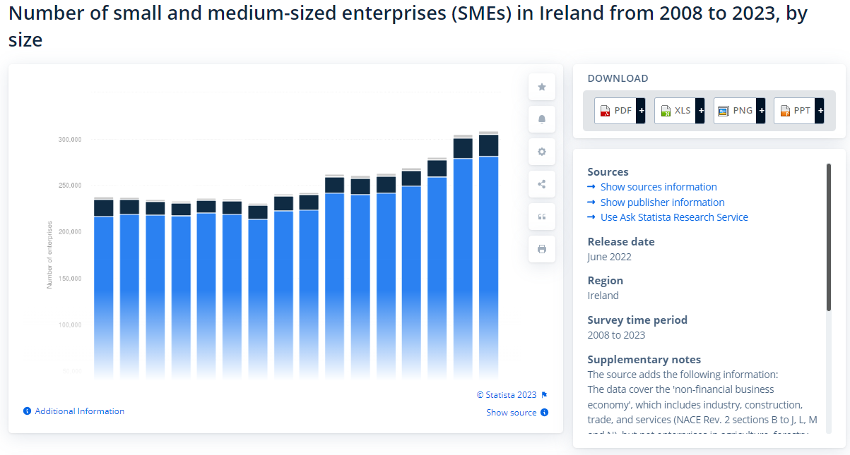

**Company Overview:**

**ADA Web Design** is a dynamic digital marketing agency in Ireland that specializes in offering comprehensive solutions to small and medium-sized businesses (SMEs) and individuals. Company’s expertise includes the design of visually attractive websites, captivating company logos and graphics, smart Search Engine Optimization (SEO), smooth e-commerce integration, and a variety of other services adapted to its clients' various demands.

The word "ADA" has unique meaning because it is derived from the initials of our team members' first names: Anastasiia, Daniel, and Adam. This abbreviation symbolizes our collaborative approach, which combines individual skills to generate cohesive and unique solutions. ADA Web Design provides organizations and individuals with a powerful and appealing digital presence in the ever-changing terrain of the Irish market.

# Project Work

How did your team split the project work? Show work packages with milestones and deliverables.

We deliberately allocated duties in our collaborative project to ensure that each team member had a thorough understanding of the project brief's ideas and requirements. We designed the work division on the website's six pages to allow exposure to various parts of development.

Specifically:

* **Anastasiia:** Led the creation of the **Home** page and undertook the development of the **Blog** section.
* **Daniel:** Took ownership of crafting the **About Us** page and managing the **Contact Us** section.
* **Adam:** Focused on designing and implementing the **Portfolio** page, in addition to developing an engaging **Quiz** feature.

This strategy not only ensured that each team member had a well-rounded skill set, but also allowed for the display of individual skills in various aspects of web design. Furthermore, to effectively monitor progress, we created critical milestones and deliverables:

**Milestones:**

**Design Approval:** Achieve unanimous approval for initial design concepts across all pages.

**Development** **Completion:** Ensure timely completion of individual page development as per set deadlines.

**Integration Testing:** Conduct thorough testing to guarantee seamless integration of all pages.

**User Acceptance Testing (UAT):** Gather feedback from team members to refine and enhance the overall user experience.

**Deliverables:**

**Home Page and Blog Section:** Anastasiia delivered a polished product meeting both design and functionality criteria.

**About Us Page and Contact Us Section:** Daniel crafted and refined pages, aligning with the project's aesthetic and communication goals.

**Portfolio Page and Quiz Feature:** Adam developed and optimized components, incorporating engaging elements for user interaction.

By adhering to these milestones and producing high-quality deliverables, our team ensured a cohesive and successful execution of the web design project.

We progressed through the project by collaborating via our GitHub repository [ 3 ].

It took us **76 commits** [4] to the main branch, **11 pull requests** [5] and **32 auto-deployments** [6] to production to get from the initial boilerplate code to the finished project.

# Design Process

Colour palette, fonts used, buttons used etc. Lots of images and reasons why certain things were done the way they are presented on your website. Show wireframes for each web page and reference at least one design pattern per wireframe.

**Colour palette:**

We used [this link](#_Chibana,_N._(2016)) for inspiration on the colour scheme for the website [[7](#_Chibana,_N._(2016))]. We adapted colour scheme 19 – “Minimal Yet Warm” for our website.

**Mood board:**

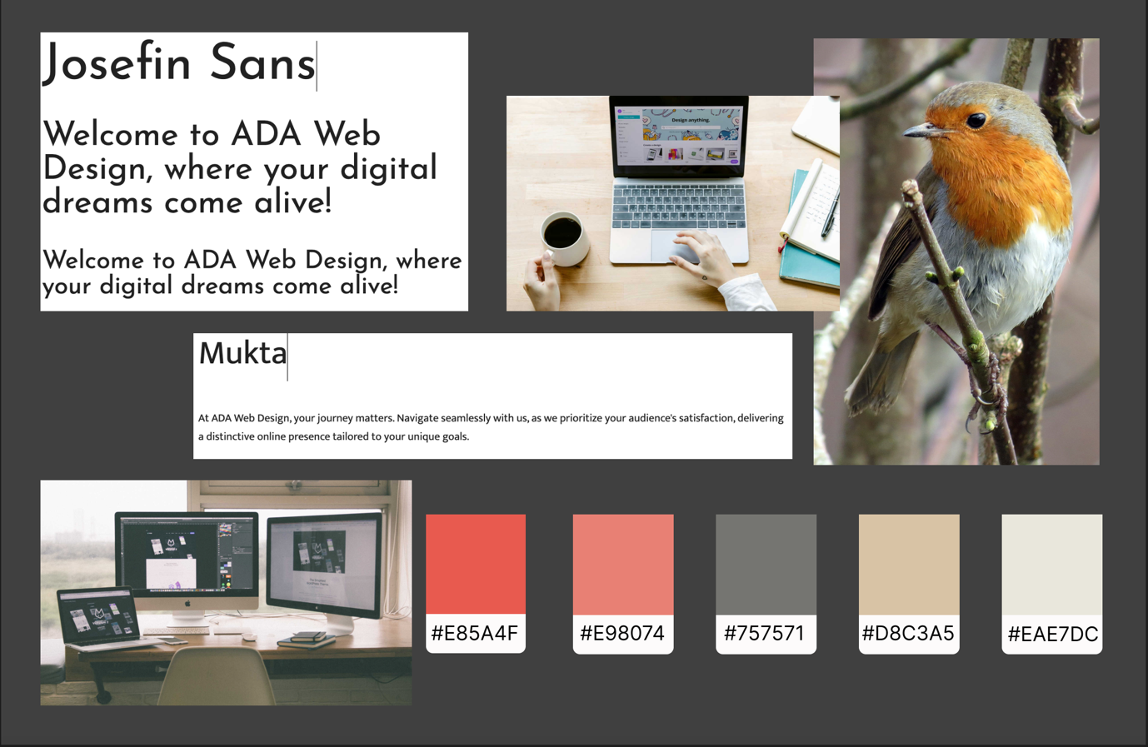

**Fonts used:**

**Mukta** was designed by Girish Dalvi and Yashodeep Gholap.

# Josefin Sans Designed by [Santiago Orozco](https://fonts.google.com/?query=Santiago%20Orozco).

These fonts are Google fonts and they are licensed under the Open Font License.

**Images:**

To ensure visually appealing user experience we used multiple images across the pages of our website that we sourced from royalty free stock photos database [2].

**Site map:**

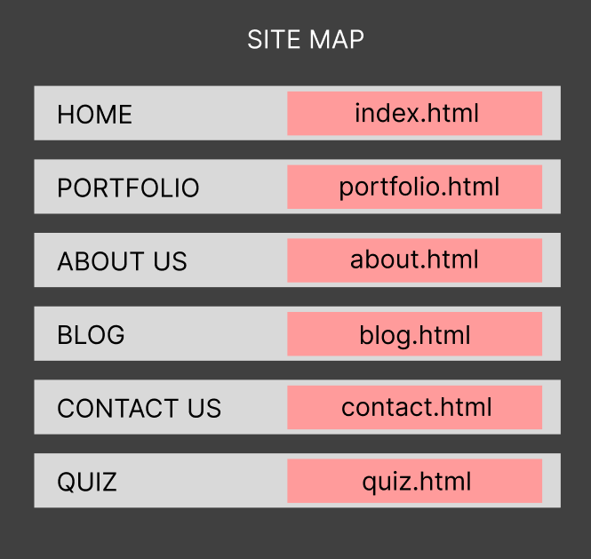

**Wireframes:**

**Homepage** (Anastasiia Kovalenko)

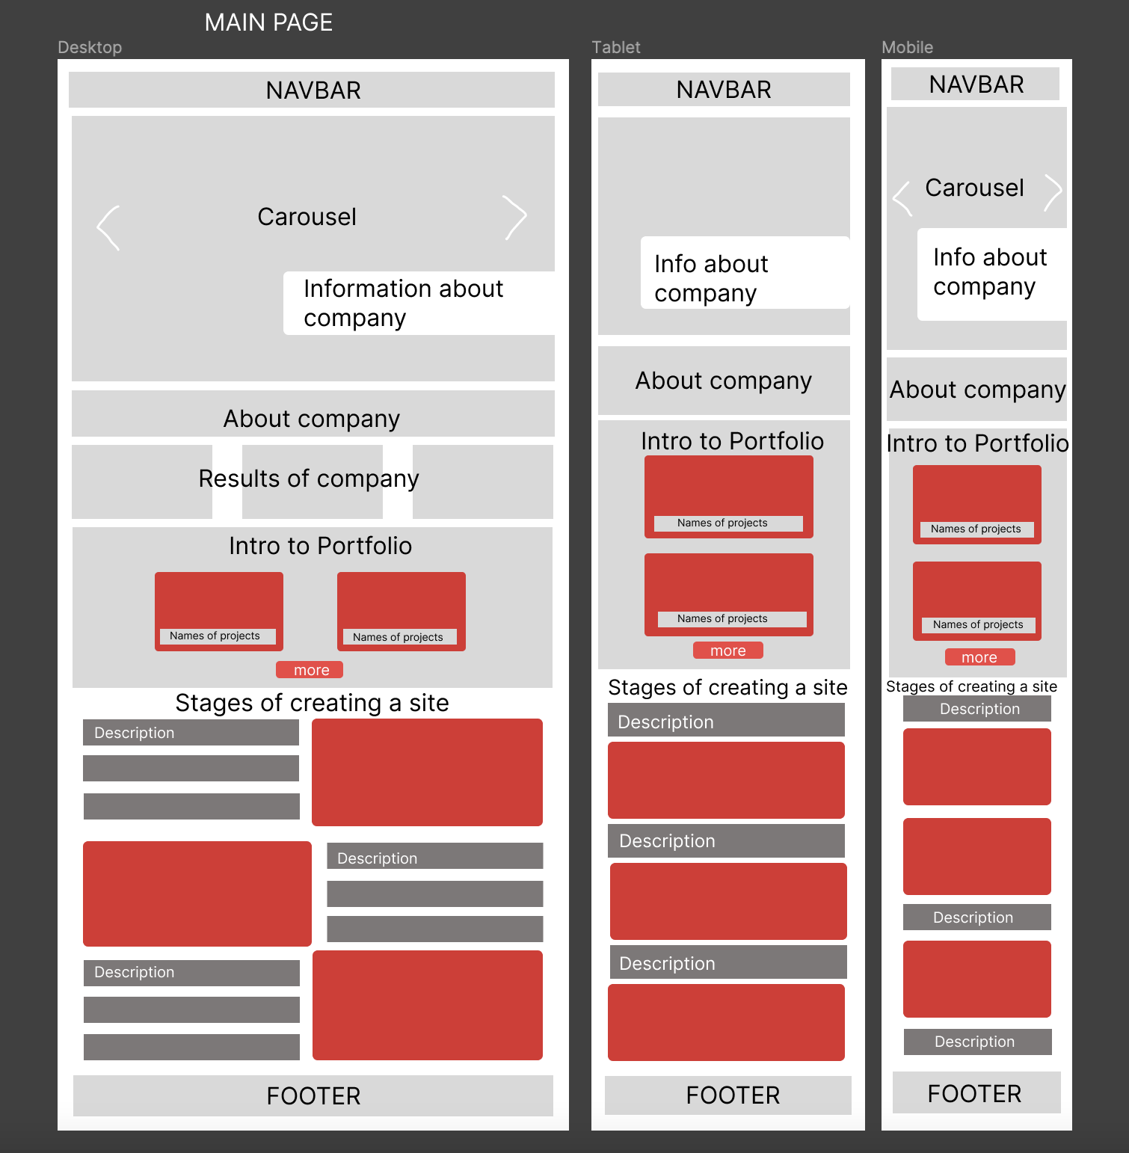

**Carousel design pattern** is used on home page. A carousel optimizes screen space and its navigational controls suggest additional content, motivating users to explore more. [8]

**Blog page** (Anastasiia Kovalenko)

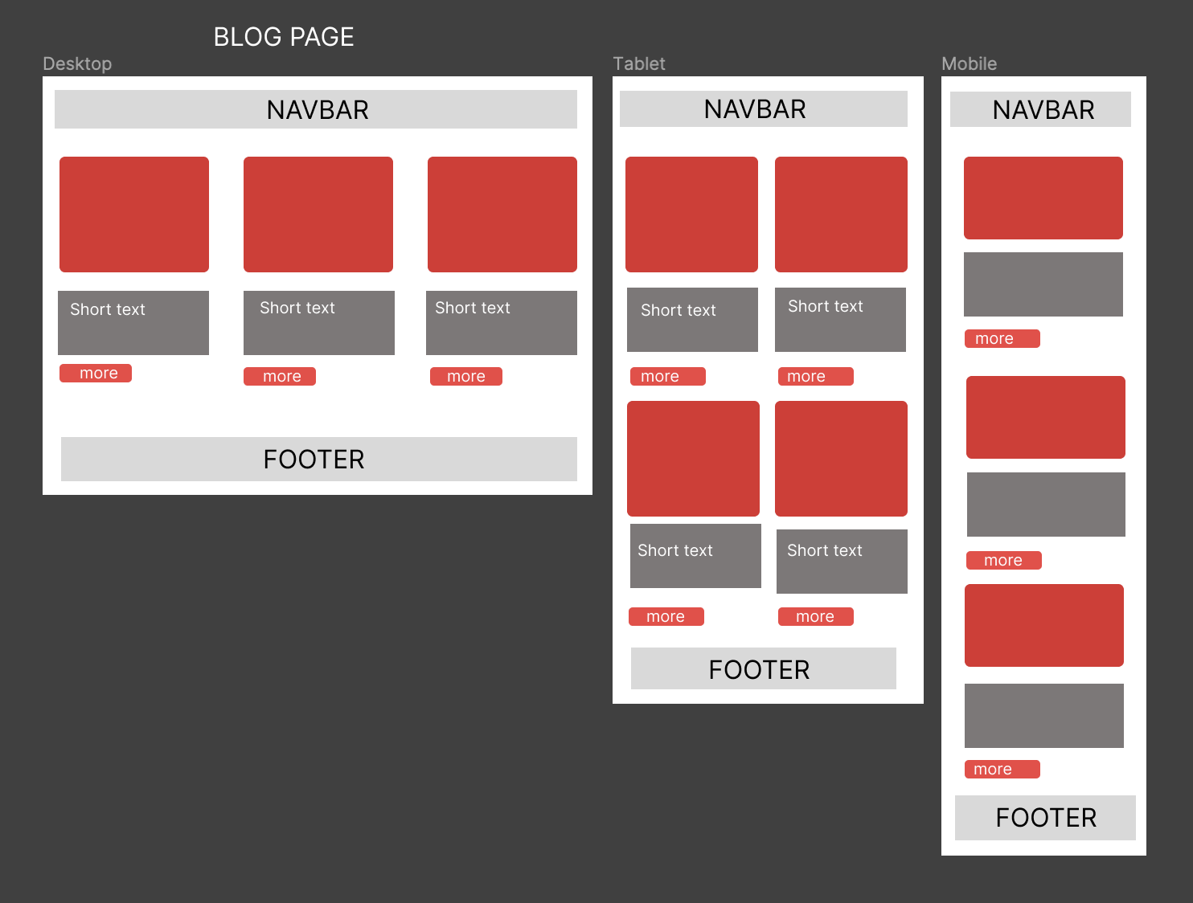

The **grid layout** is a foundational design pattern of many modern websites. This design pattern divides the page into a set number of columns of equal width and spacing between them.[[9](#_Juviler_J.,_(2022))] We use it to make site responsive – when number of columns are changed depends on screen size.

Both pages uses **Clear Primary Actions** design pattern - it makes buttons stand out with color so users know what to do.[10]

**Portfolio page (**Adam Fanslau):

Portfolio page is using **Progressive Disclosure** design pattern – it shows users minimum necessary content on the portfolio cards, with more content available in the modal visible upon clicking on the card.[10]

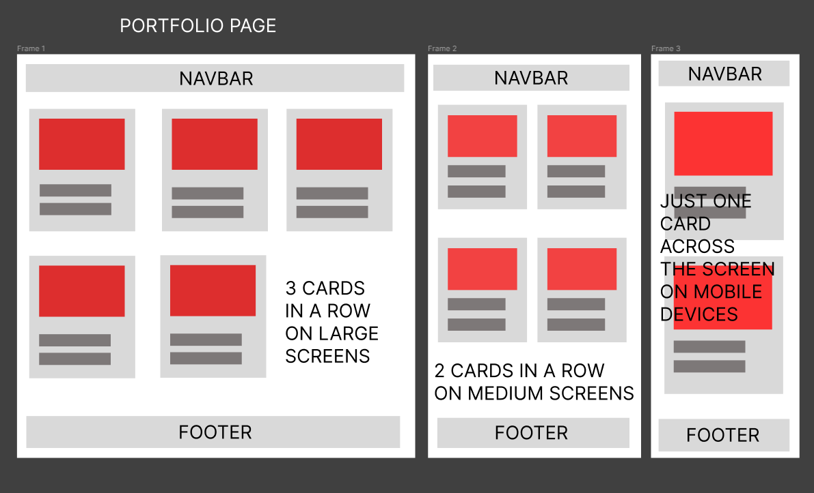

**Quiz page** (Adam Fanslau):

Quiz page uses **Clear Primary Actions** design pattern – it has large, centred button making it easier for the user to know what action to take on this page.[10]

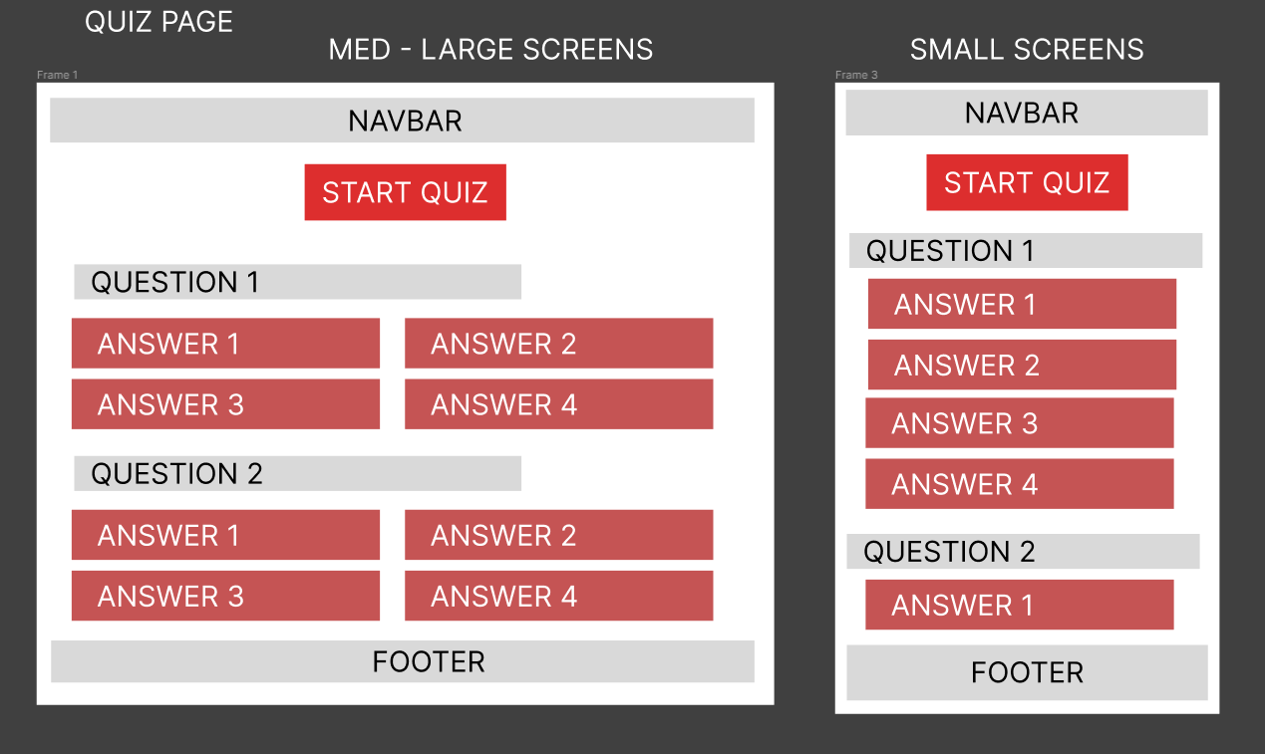

**About us page** (Daniel Lemos):

**Progressive Disclosure** design pattern was used on this page as it involves revealing information gradually and only presenting the most essential information to users upfront.

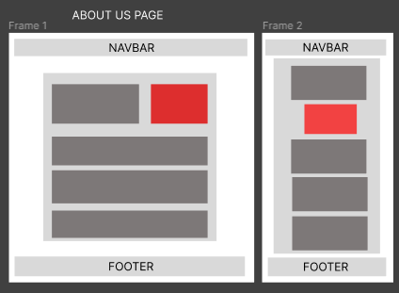

**Contact us page (**Daniel Lemos):

For this page, **Observer** design patterns was used as it enables a subscriber to register with and receive notifications from a provider. It's suitable for any scenario that requires push-based notification

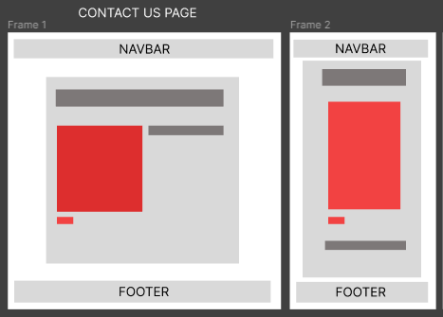

# Testing & Responsiveness

Talk about website responsiveness here along with Optimisation, SEO and Testing. You can talk about how you made your website responsive. You could also mention how you used JavaScript: loops, if statements, etc. How you deployed your website?

Our website looks really good on all screen sizes. We took advantage of the built-in responsiveness of Bootstrap framework, but also added our own custom media queries to ensure good user experience on desktops, tablets and smartphones.

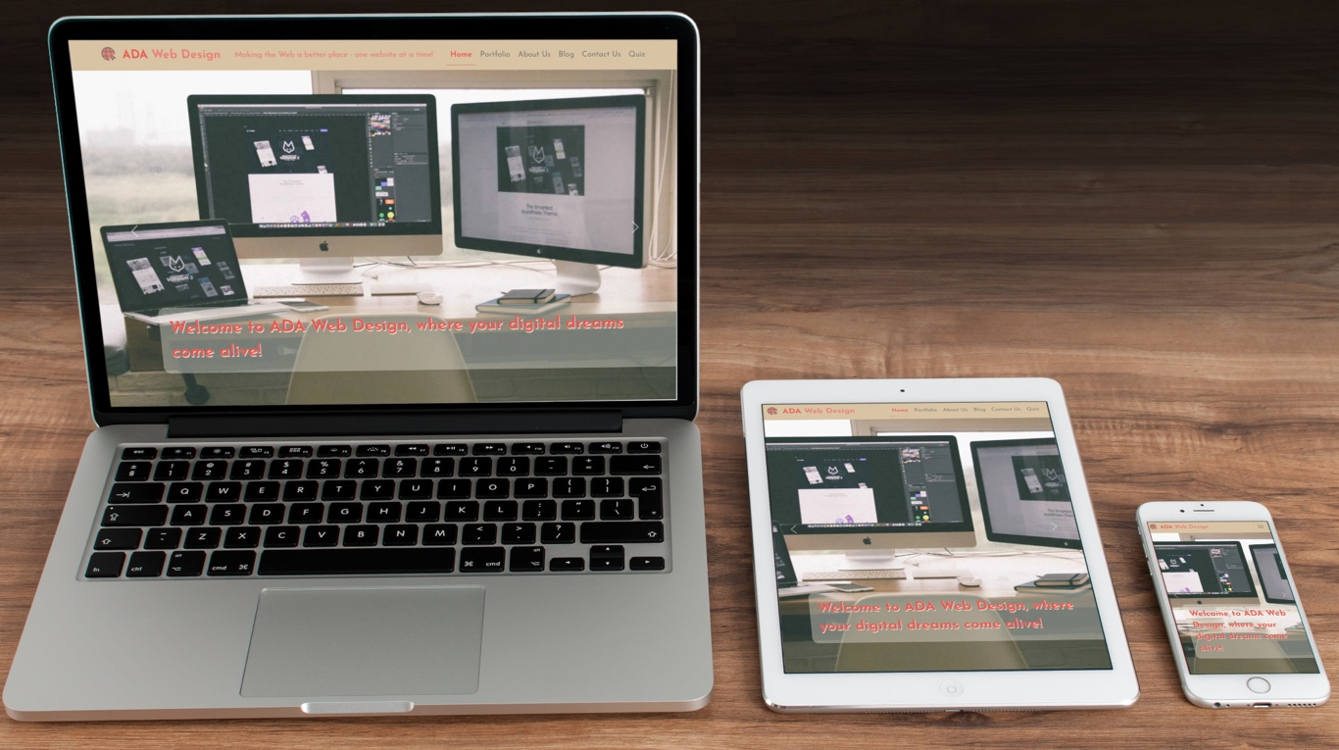

To optimize our website, we did the following:

* We used hosting on servers physically located in Ireland to ensure quick load times for Irish users
* We used modern **.webp** format for all the images, and worked on balance between good compression and good quality of all the graphics used across all the pages

For good SEO and Accessibility, we made sure the metatags with title and description are present on all pages. We also added alt attributes to our images.

We tested all the pages of our website with:

* Html validator:

Index.html

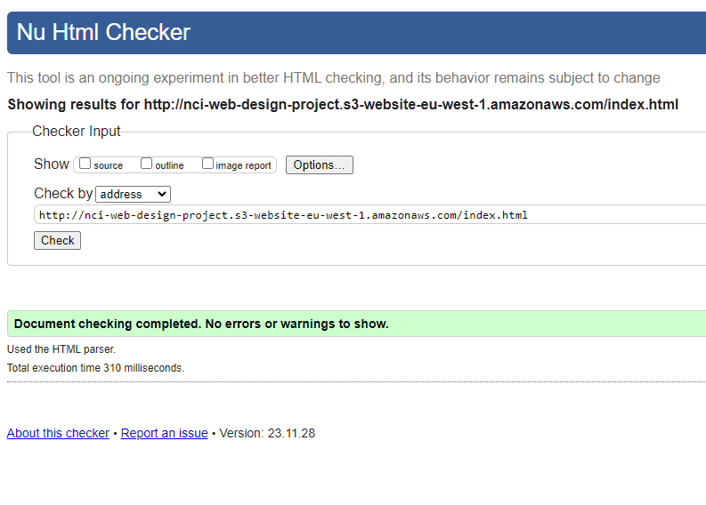

Blog.html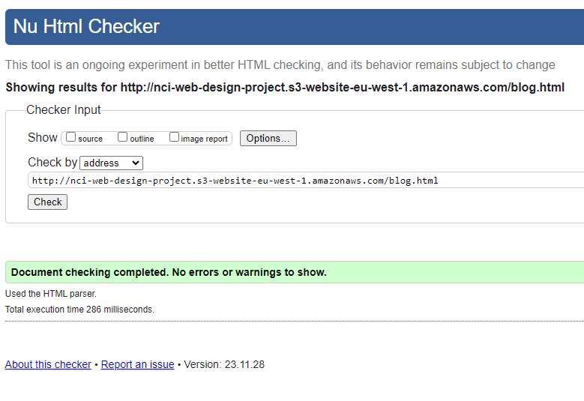

Contact.html

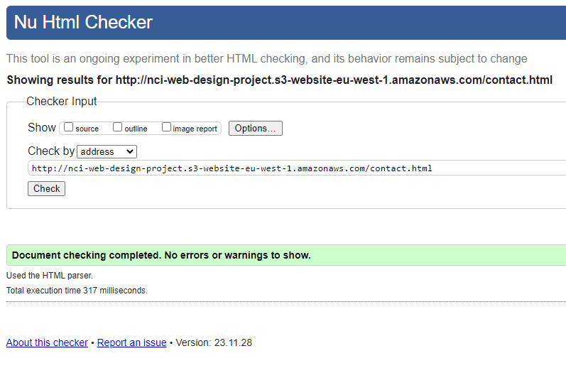

Portfolio.html

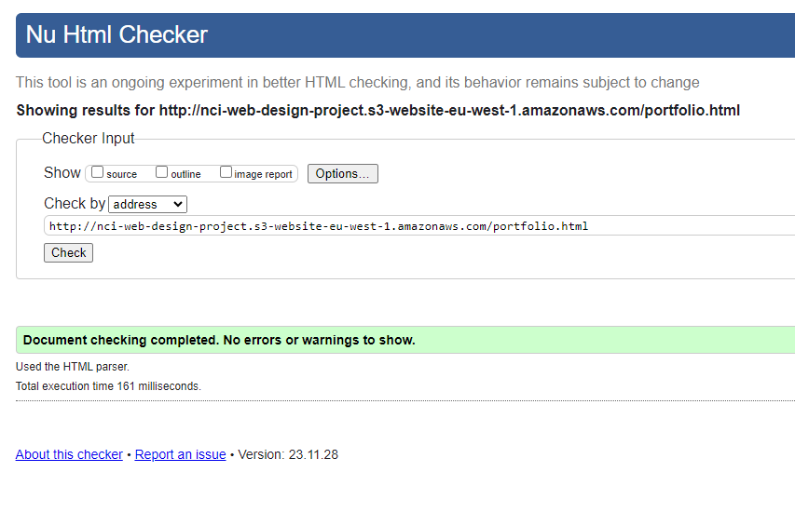

Quiz.html

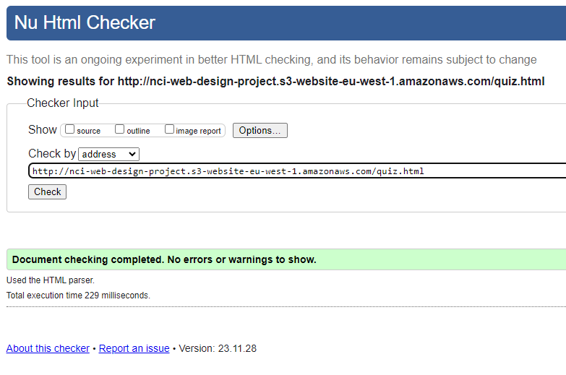

About.html

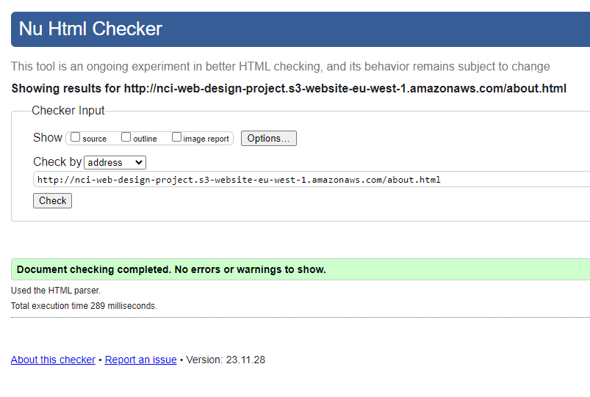

And CSS validator:

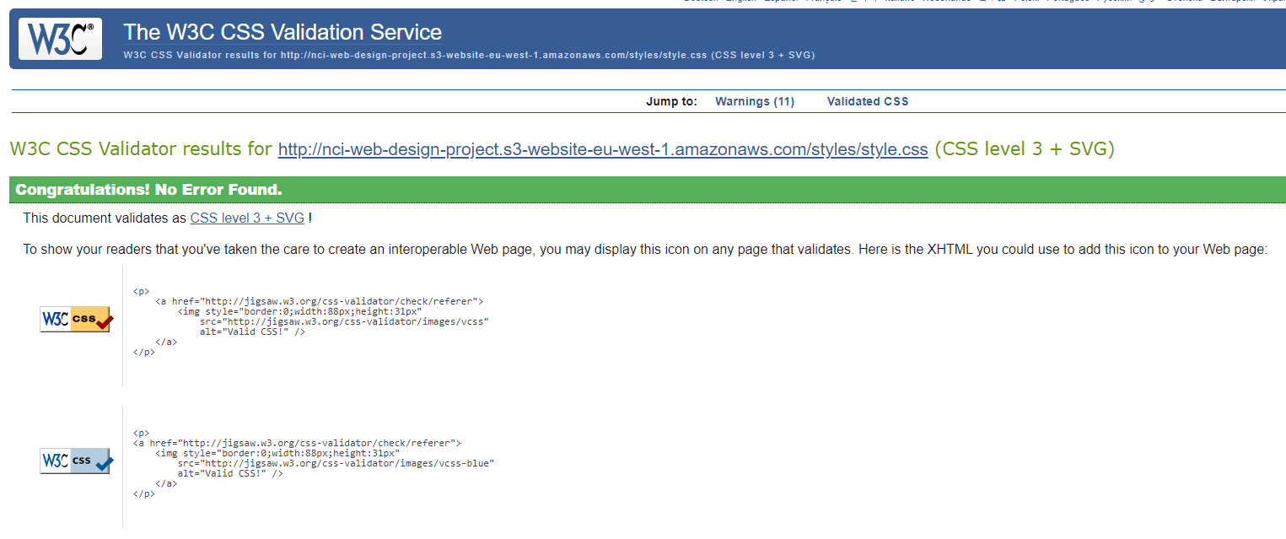

We also checked our project’s performance with Google Speed Insights:

* For desktop

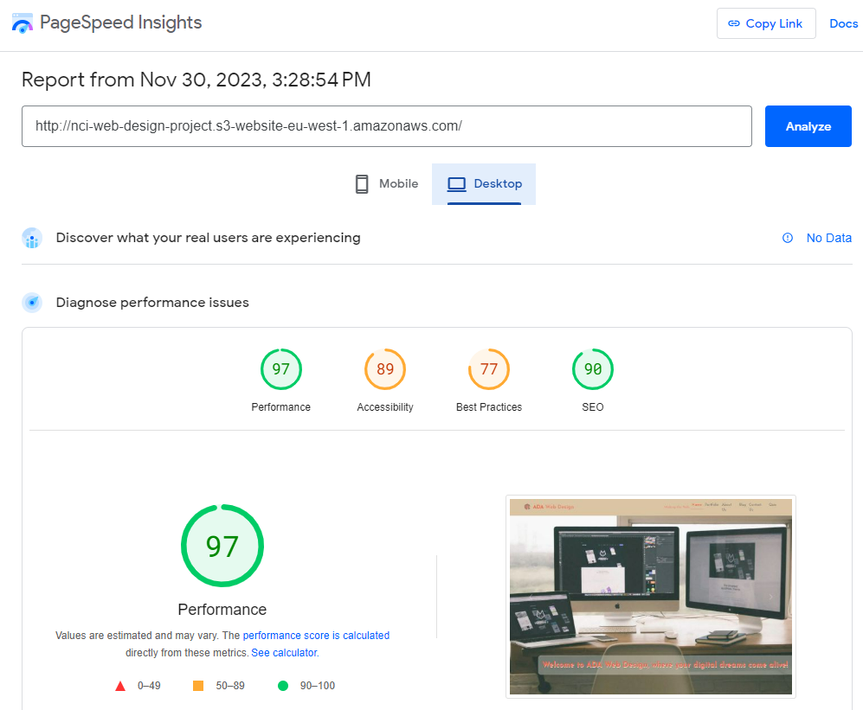

* And mobile:

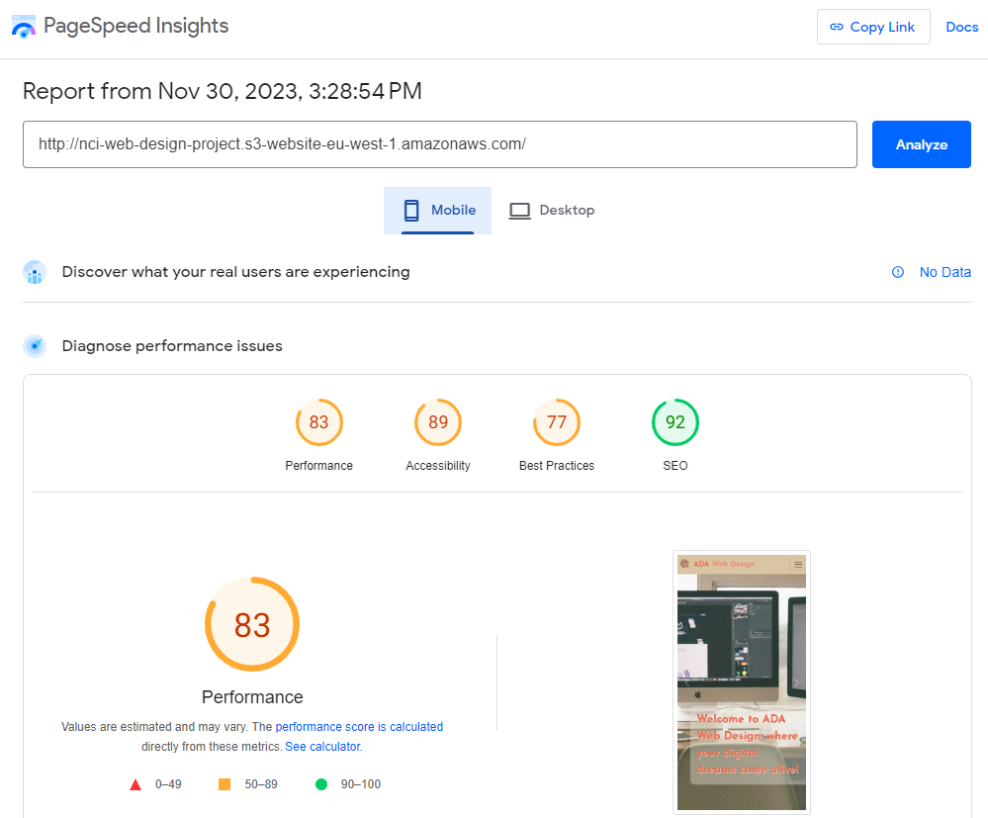

**Use of JavaScript in the project:**

We used JavaScript in our project in every single page. We have a newsletter signup form in the footer that uses JS email address **validation**. There’s more **form validation** on our contact form. Blog page uses JavaScript to populate the blog posts on the page. There is more **DOM manipulation** on the homepage with carousel description toggle triggered by click event on carousel images. And our quiz script is using multiple **event listeners**, **for loops**, an **if / else statement**, and **randomization**.

**Deployment:**

ADA Web Design website is deployed to **AWS S3** static web hosting service in **eu-west-1 region**. This data centre is located in Ireland, which was our conscious choice.

Also, we use **auto deployment** through GitHub actions, with GitHub workflow triggered by any pushes to main branch of the repository.

# Conclusion

Overview of how the project went, did you work together well as a team? What was difficult to do, how you feel the website looks and if you had time, would you make any changes?

Our web design project's progress has been distinguished by the synergy of our dedicated team and a commitment to quality. Constant collaboration fostered creative debates and built an innovative website through numerous meetings, idea exchange, and brainstorming sessions.

While the voyage was mostly smooth, one significant hurdle arose: enhancing speed optimization for both mobile and desktop versions. Navigating the complexities of responsive design required a collaborative effort. We achieved a balance through iterative testing, providing seamless functioning and aesthetic appeal across several devices.

Even though the project went smoothly, there is always space for improvement. In the future, we may improve our testing phase for performance optimization, guaranteeing that all aspects match the highest requirements.

Adaptability and constant improvement are important to our team. In retrospect, our collaborative spirit and drive of quality helped us overcome hurdles, resulting in a site design that not only meets but surpasses expectations. Lessons learnt will influence future projects, keeping us committed to quality and continuous improvement.

# References

# D. Clark, (2023) Number of small and medium-sized enterprises (SMEs) in Ireland from 2008 to 2023, by size. Available at: <https://www.statista.com/statistics/879089/number-of-smes-in-ireland/> [Accessed 10 Nov 2023].

# Royalty free stock photos database - <https://www.pexels.com/>

# GitHub repository - <https://github.com/adamfanslau/nci-web-design-project>

# GitHub Commits - <https://github.com/adamfanslau/nci-web-design-project/commits/main>

# Pull requests - <https://github.com/adamfanslau/nci-web-design-project/pulls?q=is%3Apr+is%3Aclosed>

# GitHub CD Actions - <https://github.com/adamfanslau/nci-web-design-project/actions>

# Chibana, N. (2016) 50 Gorgeous Color Schemes From Award-Winning Websites. Available at: <https://visme.co/blog/website-color-schemes/> [Accessed 14 November 2023]

# Carousel design pattern - <https://ui-patterns.com/patterns/Carousel>

# Juviler J., (2022) The Beginner's Guide to Web Design Patterns. Available at: <https://blog.hubspot.com/website/design-patterns> [Accessed 16 November 2023]

# Interaction Design Foundation - IxDF. (2016). What are User Interface (UI) Design Patterns?. Available at: <https://www.interaction-design.org/literature/topics/ui-design-patterns> [Accessed 17 November 2023]